So How Dangerous is the Covid Virus?

After two years of battling with pandemic conditions, it is very hard to question the pandemic itself. Querying figures announced by governments, or challenging the experts, seems to question “science itself”. It may even seem a betrayal of the suffering and tragedy that Covid has brought to many.
Contradicting the global picture of the pandemic also leads to the question, ‘why?’ Why would any government contradict its own data to ‘fabricate’ a narrative? Why would they scare us so? Weighed down by two years of pandemic reporting, and without any obvious reason, the idea that the pandemic is a ‘mistake’ or a ‘deception’ seems absurd. No wonder opposing voices are criticized, labelled as ‘anti-vaxxers’ and ‘conspiracy theorists’. We can see evidence of an unprecedented wave of censorship that has silenced experts across the world since the pandemic began. Yet the right to question government policy underpins free speech and democracy. Liberty to investigate accepted facts, lies at the heart of good science. It differentiates debate from propaganda.
With the virtue of hindsight, we can now investigate:
- How bad was the death rate?
- How many ‘excess deaths’ were there?
- Who died – and why?
- Were hospitals ‘overrun’?
- How serious is the virus as an illness?
- What about new variants?
- How serious is ‘long Covid’?
- What happened to open debate?

How bad was the death rate?
When we look back at the available data, we see that cases rose in early March 2020, and peaked around mid-April 2020. They then fell, forming the typical bell curve that you expect to see in respect of cases of a virus (see the blue line in the graph below). The graph also plots the number of Covid deaths during the first wave in 2020 (see the red line).
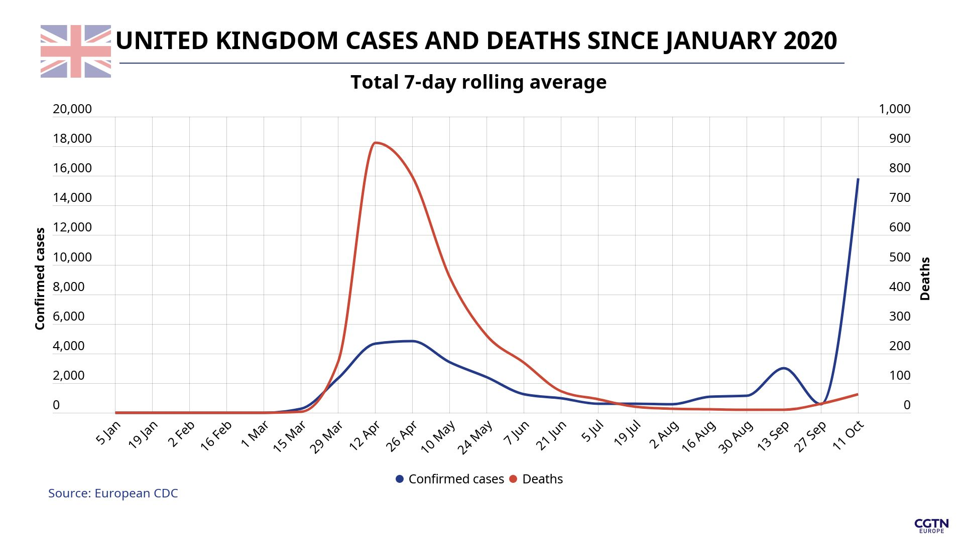
Yet there are clear issues with the accuracy of the death figures. Firstly, anyone who dies within 28 days of a positive PCR Covid test is counted as a Covid death. In other words, the statistics monitor ‘death with Covid’, not ‘death from Covid’. In addition, research has shown that people who die have an average of 2.9 co-morbidities – other illnesses that cause death.
Reviewing the available data supplied by various Government agencies, we can we see that death from Covid alone (i.e. with no other co-morbidities) from the start of the pandemic to the end of the 2nd quarter of 2021 was 16,261. By comparison, we found that in 2018, deaths from flu & pneumonia had been far higher, at 29,451.
The inaccuracy of death rates is further exacerbated by the ubiquitous reliance on PCR tests as the measure. PCR tests are widely accepted as being unreliable (even by the person who invented them). Thus, they produce a misleadingly high percentage of false positives. As such, the figures of those who died “with” Covid are likely to be far lower than reported.
Matters were not helped by some wildly inaccurate projections of Covid deaths supplied to the government by advisors such as Neil Ferguson’s group at Imperial College London (ICL). The extent of inaccuracy can be show, for example, by ICL’s prediction for Sweden. In March of 2020, ICL projected that if Sweden maintained its then response of ‘no lockdowns’, deaths in Sweden would pass 40,000 shortly after 1st May 2020 and continue to rise to 96,000 deaths by June 2020. Although Sweden maintained its low impact response, its total Covid death count as of March 2021 was a little over 13,000. The ICL modelers played a direct and primary role in selling the concept of lockdowns to the world. The governments of the United States and United Kingdom explicitly credited Ferguson’s forecasts on 16th March 2020, with the decision to embrace the once-unthinkable response of ordering their populations to stay at home.

How many excess deaths were there?
Another metric that assists with assessing the seriousness of Covid, is the number of excess deaths (i.e. deaths above average) during the pandemic year of 2020. This was falsified by the BBC, when it claimed that:
“There were close to 697,000 deaths in 2020 – nearly 85,000 more than would be expected based on the average in the previous five years. This represents an increase of 14% – making it the largest rise in excess deaths for more than 75 years.”
The true figures, once age standardized, are provided by the Office of National Statistics (ONS), which showed that there were 608,002 deaths in 2020 making it the highest excess deaths since 2008. Yet the increase in excess deaths as a percentage reported by the BBC was especially misleading as 2019 happened to be a low deaths year and it also failed to take note of the age standardized numbers of excess deaths in previous years.
If we compare excess death rates in 2020 for various countries around the world (see graph below), we can see that Sweden – without lock down, mandatory restrictions or school closures – had much lower excess deaths compared to the UK, with its lockdowns, restrictions and school closures.
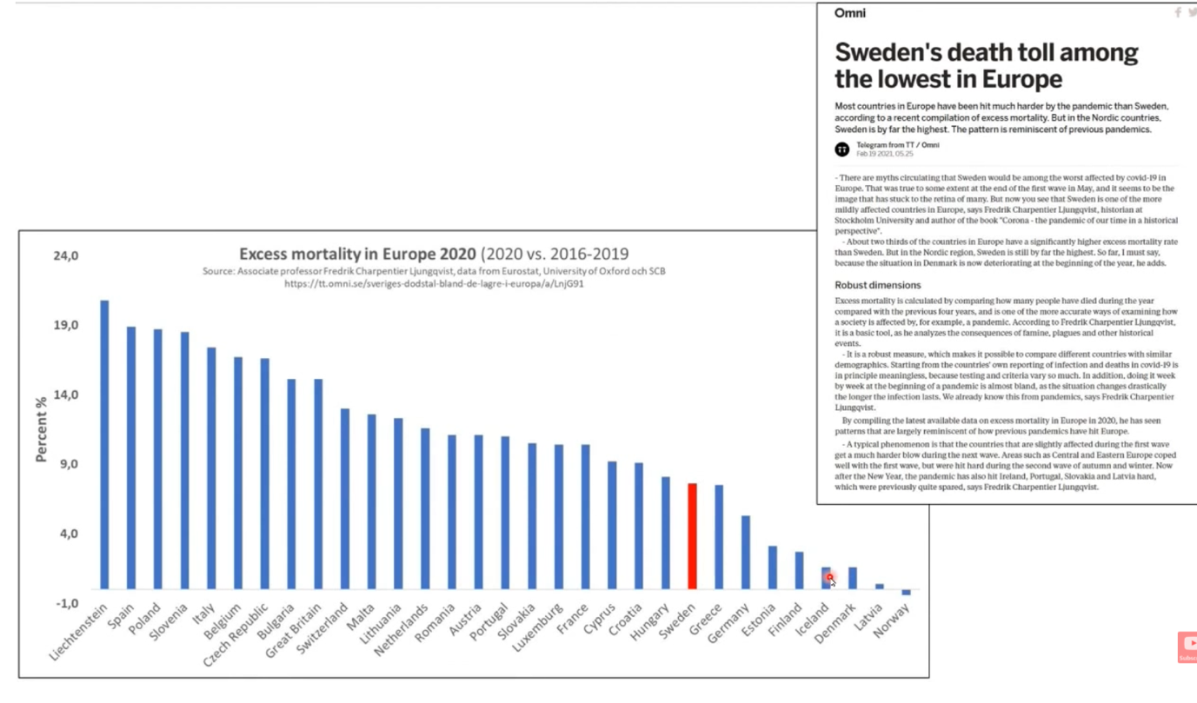

Who died – and why?
The Covid virus, although highly infectious, sadly effects people who are very old, very sick, or in the last months of life. These are the same elderly and vulnerable people who succumb to flu. The good news, in respect of Covid, is that the average age from a Covid death in the UK is not significantly different than the average age of death in the UK for ‘all cause’ mortality:
- Average age of a Covid death in the UK is 83;
- Average age of death in the UK (all cause mortality) is 82 for males and 85 for females.
Thus, Covid is age stratified in terms of impact (i.e. it tracks normal mortality).
People in a hospital or care settings are the most vulnerable. Early in the pandemic, hospitals had a policy of moving as many elderly Covid patients out of hospital into care homes, as soon as possible. This in hindsight turned out to be a disastrous move, as it meant that Covid spread through care homes that were ill-prepared for dealing with an infectious virus. Many elderly may have died in this way.
The death rate may also have been affected by an apparent change in policy regarding resuscitation of elderly, frail and vulnerable patients. A new blanket policy of ‘Do not resuscitate’ (DNR) was introduced, in respect of patients aged over 60. This, along with the an apparent increased administration of midazolam (an end of life drug), without case-by-case examination, is an extraordinary change from usual practice, the effects of which have yet to be discovered. In some cases (in particular the USA), we saw the incorrect treatment of patients with a dangerous new drug called remdesivir and inappropriate use of ventilators.
Above all, the perceived seriousness of Covid was affected by another unusual government policy. Contrary to usual medical practice of treating disease early in its onset, the government advised patients to ‘stay at home’ and call for an ambulance in the case of a dramatic decline. Officials stated there is no available early treatment for Covid. In fact, early treatments were readily available, many with proven track-records. Doctors across the world who embraced such protocols reported vast reductions in hospitalization and deaths. Yet (perhaps to boost the vaccine policy) the government and mainstream media began censoring these reports early in the pandemic. Had early treatments been advised – as happened elsewhere – many lives could have been saved, making Covid ‘just another’ potentially serious, but usually treatable illness.

Were hospitals ‘overrun’?
Hospitals certainly felt the brunt of Covid. There were fewer beds available, due to the government policy of reducing the number of beds in wards to provide social distancing for patients. There were also fewer nurses available due to PCR testing and nurses testing positive and having to stay off work (even if they had no symptoms – i.e. a false positive). Even so, a SAGE paper claimed that a staggering 40.5% of Covid infections in the first wave were caught in hospital. Yet despite all this, the NHS appear to have managed to cope with Covid admissions. Additional facilities, known as ‘Nightingale Hospitals’, were built, but in the main, remained unused. In fact, hospitals were said to be so quiet during the first six months of the pandemic that nurses were making tic-tok dance videos, as if to prove the point.

How serious is the virus as an illness?
Covid-19 was first classified as a ‘high consequence infectious disease’ (HCID) in the UK on 16 January 2020, when it was still known as the “Wuhan novel coronavirus”. HCIDs are serious diseases that arrive in the UK from other countries, and have the potential to spread domestically. According to the UK government’s definition, an HCID has several features among which is a ‘typically high case-fatality rate’. As of 19 March 2020, COVID-19 was no longer considered to be a high consequence infectious disease (HCID) in the UK – mainly because better information was showing mortality rates to be low overall.
Using the available data, a Stanford epidemiologist produced a study that provided the estimates of the survival rates for Covid infections. Listed by age groupings, we see that chances of survival, even for over 60s, is very high:
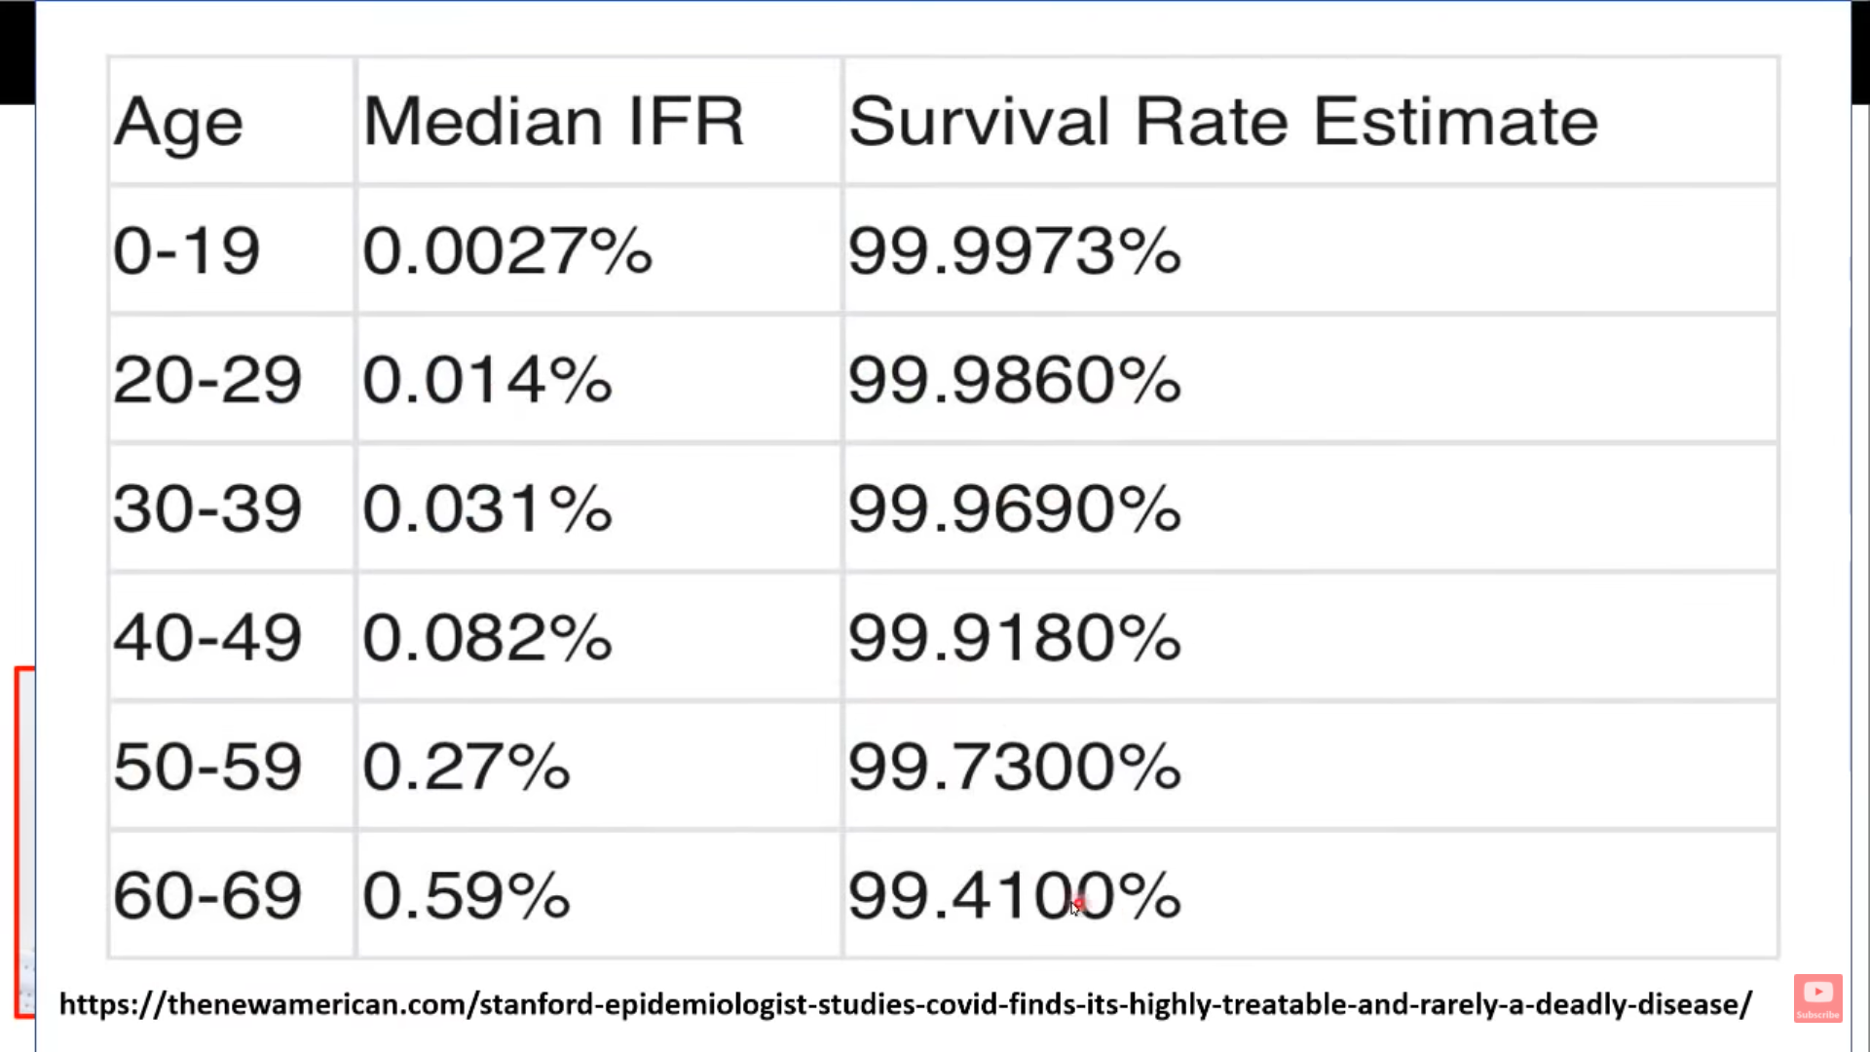
These findings are supported by data from the CDC (US ‘Centers for Disease Control and Prevention’). Here, a graph showing fatality ratios again shows that the chances of survival are very good, even with pre-existing conditions (blue data shows people with no pre existing conditions and red data shows those with pre existing conditions):
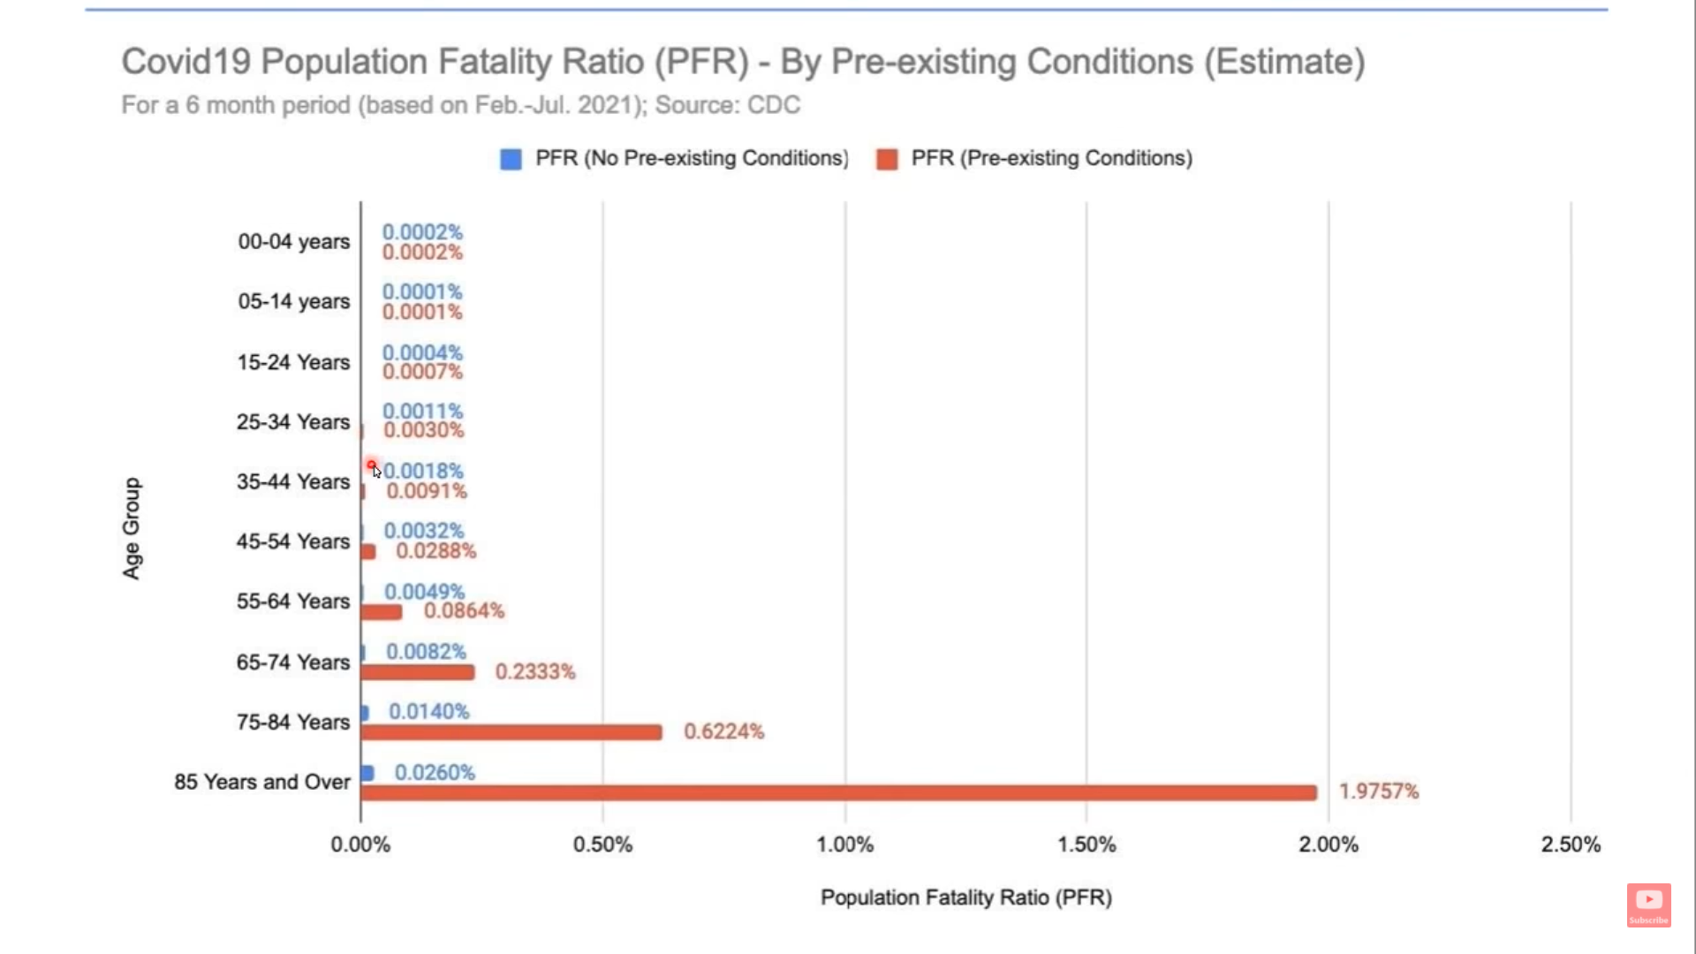

What about new variants?
Virologists state that when a virus mutates, it generally mutates as a weaker strain. It may be more infectious, but usually with lower numbers of hospitalizations and deaths. This was clearly the case with the Delta variant. Thus, as can be seen from the following graphs, although the Delta variant (wave three) was serious in terms of spread, it did not prove to be as serious as the original virus (waves one and two).

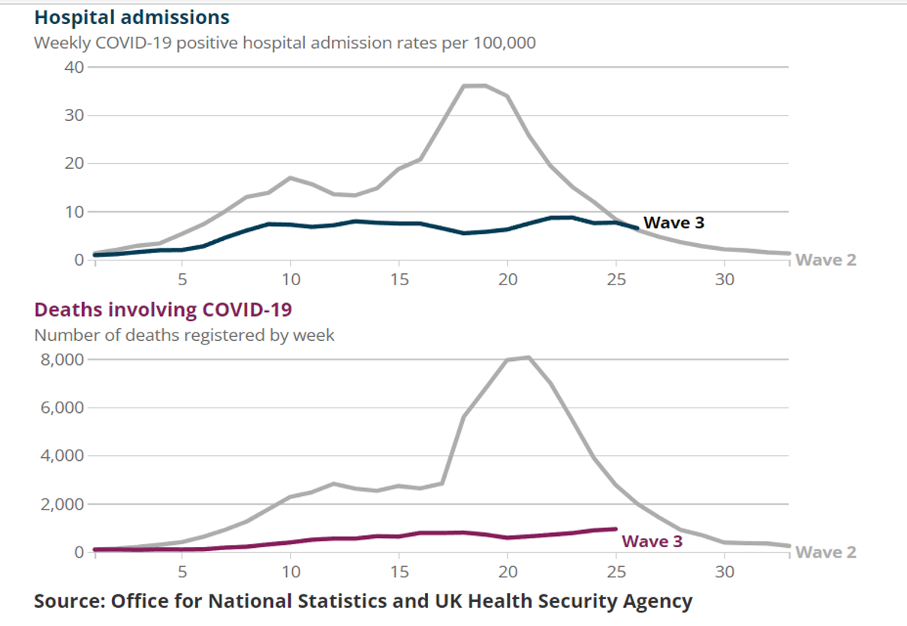
Nevertheless, the media and the Government have continued to react as if the Delta (and now, the Omicron) variant poses as high a level of threat as the original virus. This is even more remarkable because someone who has been infected with the Covid virus and recovers (‘Covid-recovered’) is found to be immune from the virus and all of its mutations. As has been found by study published in the Lancet (see next graphic).
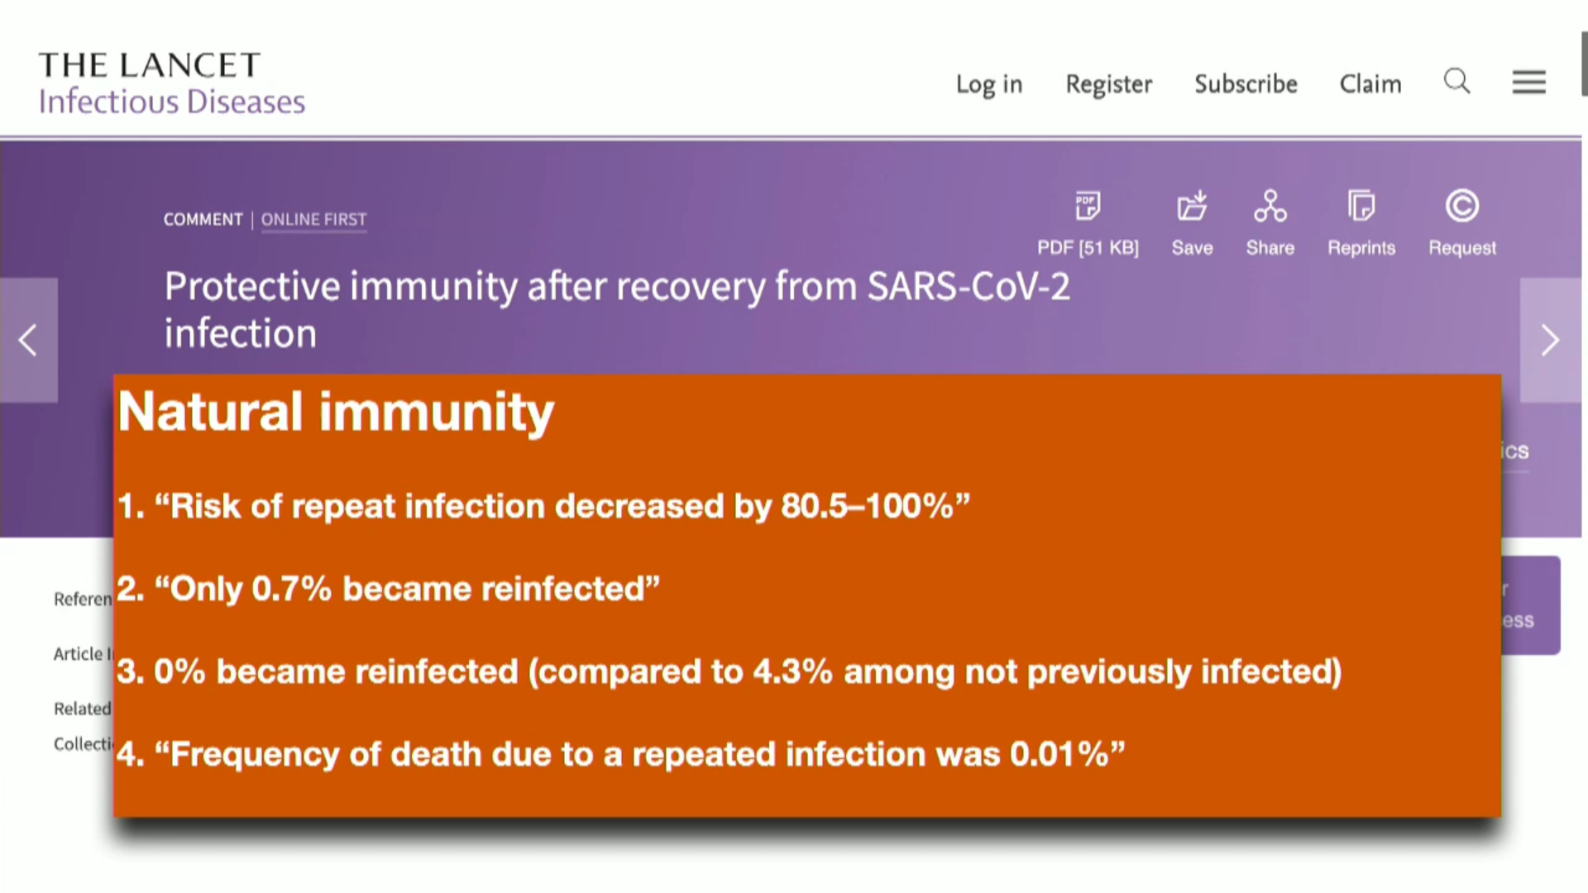
Mutations generally happen in small increments (maximum of around 3%) and ‘T Cell immunity’ can easily deal with these very slight mutations, recognize the mutation for what it is, and competently deal with it. Given there have been a high number of cases, it stands to reason that there are also a high number of people with good natural immunity. In short, virologists regard mutations as less fearful.

How serious is ‘long Covid’?
For people in low-risk categories of contagion or death, Covid is generally feared for its complications, or long-lasting symptoms known as ‘long Covid’. It is true that Covid can damage various organs, with debilitating long-lasting effect. How this compares to similar post-viral syndromes is still a topic for research as is the consequence of leaving the disease remaining unmonitored and untreated in its early stages. Any disease ‘left to itself’ until it becomes acute, is liable to create long-term damage – a risk that can be mitigated by early treatment.

What happened to open debate?
Given the consequences of the pandemic, we might have expected vigorous attention to the discrepancies and issues outlined above. In fact, a great deal of expert comment supports the alternative views offered above – but is routinely censored from mainstream news and platforms such as YouTube, Google, Twitter, Facebook, etc. By announcing a state of emergency, the government has allowed traditional and social media to silence individuals who wish to discuss or oppose the official view. Censorship has become an outstanding feature of the pandemic, itself incapable of debate.
The startling degree of censorship may be related to the new restrictions. The government, wishing to encourage compliance, may have exaggerated the level of threat. Certainly, we see that fear was a formally-recommended tactic, among others, to encourage such compliance in the general population. This itself is worrying.

Conclusion
The global response has been to portray Covid as serious enough to warrant emergency measures, including a sudden and drastic loss of freedoms in the form of lockdowns, mask-wearing, and now, mandates for vaccination and Covid passports.
The rationale for this loss of freedoms is ‘to save lives’ – despite the real figures seen above. In the UK, another emotive arguments for the emergency-level response has been the government’s plea that we ‘protect the NHS’. In contrast, previous outbreaks of flu (some with higher mortality rates) have brought calls for the government to ensure a health-care service with enough resources to ‘protect the public’.
Restrictions have been imposed to control the spread of a disease we now know to be highly treatable, and to bolster a health service – which despite huge pressures – manages to cope.
By sticking faithfully to the facts presented by government itself, we have seen that – yes –Covid undoubtedly poses a great risk to the elderly and the vulnerable, in the same way flu poses such a risk. However, the data on hospitalisations and deaths clearly shows that Covid is no more of a risk than the flu. Coupled with the use of early treatments, there is no clear reason to turn Covid into a particular threat; nor to make Covid a source of fear, for which we give up our freedoms without further debate.

References

https://www.cdc.gov/nchs/data/health_policy/covid19-comorbidity-expanded-12092020-508.pdf
This is the latest data at the time of this article (Nov 2021): www.ons.gov.uk/peoplepopulationandcommunity/birthsdeathsandmarriages/deaths/datasets/preexistingconditionsofpeoplewhodiedduetocovid19englandandwales
www.ons.gov.uk/aboutus/transparencyandgovernance/freedomofinformationfoi/influenzadeathsin20182019and2020
www.standforhealthfreedom.com/wp-content/uploads/2021/01/The-Problems-With-PCR-Testing.pdf
Imperial College Model Applied to Sweden Yields Preposterous Results – AIER. Sweden’s Covid deaths per million of population figures (as at May 2021) stands at 1,443 compared to the UK’s figure of 1,888: The Failure of Imperial College Modeling Is Far Worse than We Knew – AIER.
www.aier.org/article/imperial-college-model-applied-to-sweden-yields-preposterous-results/
www.bbc.co.uk/news/uk- 55631693#:~:text=The%20Covid%20pandemic%20has%20caused%20excess%20deaths%20to,in%20excess%20deaths%20for%20more%20than%2075%20years.
www.ons.gov.uk/aboutus/transparencyandgovernance/freedomofinformationfoi/deathsintheukfrom1990to2020
www.ons.gov.uk/aboutus/transparencyandgovernance/freedomofinformationfoi/averageageofthosewhohaddiedwithcovid19
www.ons.gov.uk/peoplepopulationandcommunity/birthsdeathsandmarriages/deaths/articles/mortalityinenglandandwales/2012-12-17
www.dailymail.co.uk/news/article-8514081/Number-prescriptions-drug-midazolam-doubled-height-pandemic.html; also: The Evidence – ‘You stayed at home, to protect the NHS, but they gave Midazolam to the Elderly and told you they were Covid Deaths’ – The Expose (dailyexpose.uk)
www.theweek.co.uk/107888/nhs-care-homes-do-not-resuscitate-order-all-residents-coronavirus; also: People with mental illness and learning disabilities given ‘do not resuscitate’ orders during pandemic (msn.com); also: Doctors put us under 'do not resuscitate' orders without our permission during pandemic (thesun.co.uk) ; also: Older People Being Pressurised Into Signing Do Not Attempt Cpr Forms - Joint Statement From Age Sector Organisations | Media | Age Uk
Remdesivir, ventilation can do more harm than good against COVID – Pete Santilli reports on Brighteon.TV (pharmaceuticalfraud.com) ; also: Doctor Exposes the Dangers of Remdesivir and other Drugs that are Being Recommended by NIH - Weblyf ; also: Remdesivir and Acute Renal Failure: A Potential Safety Signal From Disproportionality Analysis of the WHO Safety Database - PubMed (nih.gov)
Ventilators: Helping or Harming COVID-19 Patients? (webmd.com) ; also: Case Fatality Rates for Patients with COVID-19 Requiring Invasive Mechanical Ventilation. A Meta-analysis - PubMed (nih.gov)
Stay at home: guidance for households with possible or confirmed coronavirus (COVID-19) infection - GOV.UK (www.gov.uk)
The issue of censorship is covered elsewhere (see: Comply/Debate). Here, we give two notable examples: The case of Dr Peter McCullough in the US, and Dr Sam White, GP in the UK: ⁣Dr. Peter McCullough | COVID Censorship is a Manifestation of Fear (brandnewtube.com) and BREAKING NEWS | peckford42 (wordpress.com)
www.assets.publishing.service.gov.uk/government/uploads/system/uploads/attachment_data/file/961210/S1056_Contribution_of_nosocomial_infections_to_the_first_wave.pdf
Delta or Indian Variant - Real World Impact? We Now have the DATA! - YouTube ; also: We shouldn’t worry when a virus mutates during disease outbreaks | Nature Microbiology or in pdf format: www.nature.com/articles/s41564-020-0690-4.pdf; also: We shouldn’t worry when a virus mutates during disease outbreaks (nih.gov) ; also: Is the coronavirus mutating? Yes. Here’s why you don’t need to panic | Science News
We shouldn’t worry when a virus mutates during disease outbreaks (nature.com) ; also: Don't buy the hysteria: The Delta variant is actually less dangerous (nypost.com) ; also: Coronavirus (COVID-19) latest insights - Office for National Statistics (ons.gov.uk)
SPI-B recommended to the Government that ‘the perceived level of personal threat needs to be increased among those who are complacent, using hard-hitting emotional messaging’. See the report at: 25-options-for-increasing-adherence-to-social-distancing-measures-22032020.pdf (publishing.service.gov.uk)

