Covid Vaccines – Are They Safe & Effective?

The government maintains that Covid vaccines are safe and effective. Most media outlets, too, focus almost solely on the benefits of vaccination, and the dangers of remaining unvaccinated. However, there is growing evidence emerging that the vaccines may not be as safe and effective as they suggest. To explore the subject thoroughly, we need to turn to the government’s own statistics. Here, we follow statistics provided by the Office for National Statistics “ONS”, or the figures published by the NHS and the Health Security Agency “HSA” (formerly Public Health England “PHE”).
When Covid first hit in March 2020, or thereabouts, we decided to follow these governmental sources of data, rather than relying solely on media outlets. We tracked the numbers of Covid cases, along with the numbers of hospitalizations from Covid, and – crucially – the numbers of deaths from Covid. This allowed us to see for ourselves the extent of the Covid problem. As we did so, we were surprised to see growing inconsistencies between the stats and the headline news. For example:
- The number of people who have died from Covid with no other co-morbidities in England & Wales from the start of the pandemic to the end of the 2nd quarter of 2021 (this is the latest data at the time of writing) was 16,261. By comparison, we found that in 2018, deaths from flu & pneumonia had been 29,451; and
- The average age of a Covid death in the UK is 83, whereas the average age of death in the UK (all cause mortality) is 82 and 85 for males and females, respectively.
Although this gave a far less worrying picture than the media presented, the elderly and immune compromised are still greatly susceptible to Covid. The real vulnerability of elderly and sick people to the virus seemed to justify the introduction of a vaccine that had not passed its full trial stages, and which is still deemed experimental. However, we were far more cautious when the vaccine roll out was offered to people who were less vulnerable – for whom the risk of serious illness and death was minimal (see Covid Risk). We were surprised to see very little discussion of the experimental nature of the vaccine, and what that might mean for the nation. It is little understood that the current Covid vaccines are in phase 4 trials until 2023. It normally takes a minimum of between 5 to 10 years to develop a vaccine and to undertake studies on different age groups, and stages of pregnancy, and possible responses to different medications, etc. Without the full studies needed to ensure the safety and efficacy of the vaccine, we were not fully reassured by the government’s faith in them, nor in the strong media ‘hype’ that seemed to surround them.

Adverse Reaction Reporting Systems
Seeking answers for our concerns, we turned to another government source for information. The Medicines & Health Regulatory Authority (MHRA) runs a reporting system for adverse reactions to vaccines and medicine, known as the Yellow Card Scheme. The system was introduced in 1964 after the thalidomide tragedy. Equivalent reporting systems exist across the world (as we see below), allowing medicines and vaccines to be monitored for safety. The schemes collect information from healthcare professionals and by members of the public alike (patients, users or carers) – anyone who has noted or experienced an adverse reaction to a drug or medicine – and this allows the regulatory bodies to monitor and investigate side effects, and to spot problems as they emerge. The MHRA website, for example, explains that the purpose of the scheme is to signal an early warning if the safety of a medicine or a medical device requires further investigation. Here, the MHRA is explicit: they will review issues and, if necessary, take action to minimize risk and maximise benefit to the patients.
Worthy as the schemes are, it is worth noting that they admit shortfalls. According to the MHRA, the Yellow Card Scheme data only accounts for approximately 10% of all serious adverse reactions, and around 1% to 4% of all minor adverse reactions to any vaccine or medicine.
The Covid vaccines are no exception in terms of reporting of adverse reactions. Three COVID-19 vaccines – the COVID-19 Pfizer/BioNTech Vaccine, COVID-19 Vaccine AstraZeneca and COVID-19 Vaccine Moderna – are currently used in the UK. All have been authorised for supply by the MHRA under an emergency authorization, “following a thorough review of safety, quality and efficacy information from clinical trials. In clinical trials, the vaccines showed very high levels of protection against symptomatic infections with COVID-19” (although recently, the BMJ and other publications have raised questions over the integrity of the clinical trials data provided by Pfizer in this respect).
It is true that all vaccines and medicines have some side effects, and these side effects need to be balanced against the expected benefits in preventing illness. While regrettable, a degree of adverse reaction is to be expected, too. Also, reported events are not always proof of side effects. Some events may have happened anyway, regardless of vaccination. This is particularly the case when millions of people are vaccinated, especially when vaccines are being given to the most elderly people and people who have underlying illness. Given all this, the MHRA’s role in investigating the adverse reactions is crucial. Its ability to respond quickly is paramount – especially if they see an unusual increase in the number of reports.
Let’s turn to the Yellow Card Scheme now and review its data on the Covid vaccines. Remembering that the data only represents around 10% of what the real numbers are likely to be, the Yellow Card Scheme reports the following (as of 3rd November 2021):
Manufacturer | Total reports | Total reactions | Total fatalities
Astra Zeneca | 236,386 | 838,831 | 1,120
Moderna | 17,321 | 55,564 | 19
Pfizer | 128,734 | 363,704 | 597
Unspecified | 1,203 | 3,602 | 32
Totals | 383,644 | 1,261,701 | 1,768

If the MHRA is correct that reports only represent 10% of serious adverse reactions and fatalities, this would point to there actually being17,000 fatalities. To put this in context, the adverse effects of the Covid vaccines are higher than all other vaccines in the history of the scheme put together. This is cause for grave concern. What is more, there is no indication that the MHRA has investigated, or intends to investigate, any of these reported adverse events. Although its stance may be explained by a wish not to undermine the current vaccine roll out, still, the government is legally obliged to keep us informed, so that we can give informed consent to the jabs – especially as the vaccines are still in their experimental stages.
Among the categories of adverse reactions listed within the yellow card data we find (among many others) the following:
- Cardiac disorders;
- Blood disorders;
- Eye disorders;
- Gastrointestinal disorders;
- Immune system disorders;
- Skin disorders;
- Vascular disorders; and
- Muscle and tissue disorders.

Concerns over heart problems
One of the common issues with these vaccines relates to heart problems. The incidences of cardiac disorder seems to have sky-rocketed, especially among younger males. A German news outlet, ‘REPORT 24’, kept track of incidences of professional athletes (mainly footballers, but also rugby players, cricketers and other sportsmen and women) suffering heart attacks either during a match or in practice sessions, and between June and October 2021, they documented 75 cases. More have occurred since and have made headline news.
A recent study from the American Heart Association also indicates that the Covid Vaccines are causing increased risk of heart issues and recent UK statistics from the ONS (see graph below) show that excess deaths (i.e. deaths above normal average figures) in people under 60 is higher among those that have been vaccinated than those who have not been vaccinated. Could the higher excess deaths in the vaccinated be linked to heart-related side effects of the vaccines?
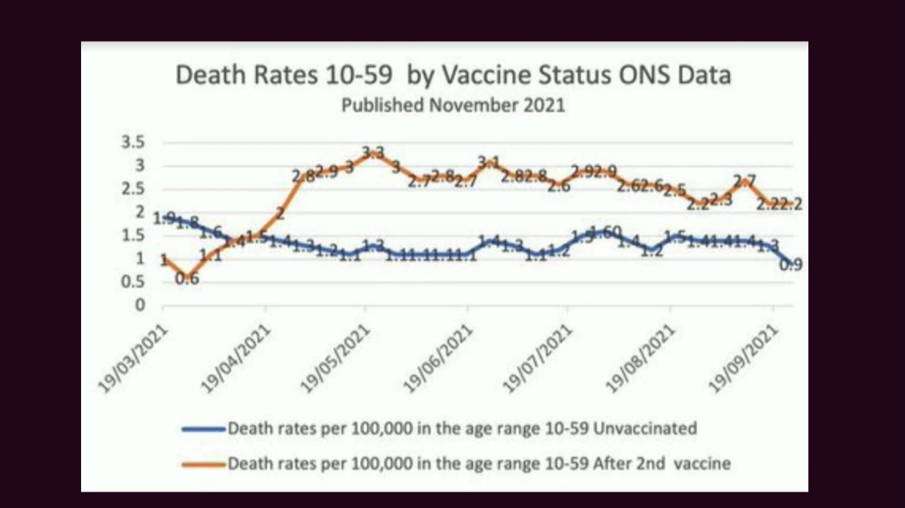

The aforementioned question is reasonable when we consider a study of 566 patients who received either the Pfizer or Moderna vaccines – in which signs of cardiovascular damage soared following the shots. Published by the American Heart Association in the prestigious paper, ‘Circulation’, we see that the risk of heart attacks or other severe coronary problems more than doubled in the months after the vaccines were administered. That is, patients had a 1 in 4 risk for severe heart problems after the vaccines, compared to 1 in 9 before. In simple terms, the risk of heart attacks more than doubled after vaccination.
Similar reactions to the vaccines are noted elsewhere, based on reporting schemes in other countries. Like the UK’s Yellow Card Scheme, these agencies also state that reported incidents represent a fraction (as low as 4%-10%) of actual cases. For example:
- In the European Union, ‘EudraVigilance’ has logged 1,038,776 reports of 2,536,526 adverse events, including 27,242 deaths (up to 9th October 2021);
- In Australia, ‘DAEN’ has logged 63,672 reports of 204,746 adverse events, including 566 deaths (up to September 29th);
- In the USA, ‘VAERS’ has logged 701,559 reports including 14,925 deaths (up to 10th September 2021);
- In Scandinavia, Sweden, Denmark, Iceland and Finland have all temporarily halted the use of Moderna’s COVID-19 vaccine for people under the age of 30, due to heart risks.
Doctors worldwide have also pointed to the alarming incidence of reactions and deaths. In June 2021, Dr Tess Lawrie in wrote an open letter to Dr June Raine, head of the MHRA, arguing that: “The MHRA now has more than enough evidence on the Yellow Card system to declare the COVID-19 vaccines unsafe for use in humans”. There have also been calls for clearer ONS data on the rise in deaths of young males in England and Wales, as investigation of official ONS data indicates that since the Covid vaccine has been rolled out to teens, there has been a significant increase in deaths in this population.
Presumably in response to all this, the Joint Committee on Vaccination and Immunisation (JCVI) refused to recommend mass vaccination for children aged between 12 and 15. However, the Government went ahead in any case. Within two weeks of that roll out, there have been 6 reports of sudden death in children of that age group in England.
Another doctor aware of the risks posed by the vaccine is Dr Peter McCullough in the USA. One of the most highly published and well-regarded academics and clinicians of his generation, and an experienced reviewer of clinical trials, Dr McCullough explains that if a new treatment shows even 25 deaths, then the trial is immediately stopped for safety reasons. He expresses puzzlement that the FDA has allowed an experimental Covid vaccination scheme to continue in the face of thousands of deaths. Although 70% of his patients have received a Covid vaccine, he no longer advises his patients to take it owing to the high incidence of severe side effects – advice that, despite his eminence in the field –Wikipedia describes as ‘contributing to Covid-19 disinformation’.

Concerns over Vaccine efficacy
Another question emerges over the government’s statement that the vaccines are ‘95% effective.’ When the vaccine manufacturers say that the vaccines are 95% effective, what they are actually saying is that the ‘relative risk’ is reduced by 95%. However, the metric that is important is not ‘relative risk’ but rather ‘absolute risk’. When you calculate the ‘absolute risk’ it turns out to be only a 1% risk reduction (as this article explains).
Using the term ‘vaccine’ is also misleading, because, unlike traditional vaccines, the new MRNA drug does not actually prevent you from catching the virus, nor stop you from spreading the virus to others. The scientific data in this respect is clear, as Boris Johnson himself has admitted on national television. Pharmaceutical manufacturers say the same: that Covid vaccines (only) reduce the seriousness of the Covid infection.
What does all this mean? Let’s take a snapshot look of the data provided by PHE (prior to its name change to HSA) in respect of weeks 36 to week 39 (6th to 27th September) of the pandemic year, 2021, as shown by people from age 30 to 80 plus. Looking at the last 3 columns, you can see the rates of Covid infections among the various age groups for vaccinated and unvaccinated persons, and the resulting effectiveness figures:
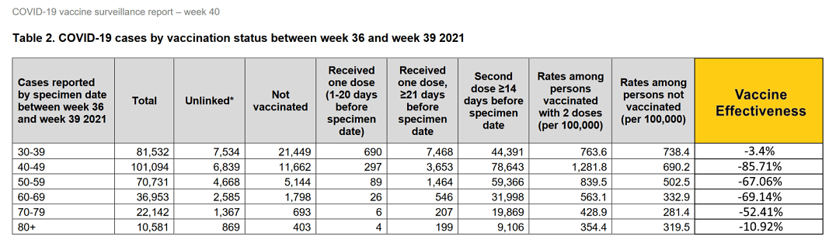

Now, here’s a snapshot of the data for week 42 (18th October 2021) from the UK HAS in those age-groups which likewise shows the rates of Covid infections among the various age groups for vaccinated and unvaccinated persons. For all age groups over 30 the cases are much higher in those that are vaccinated:

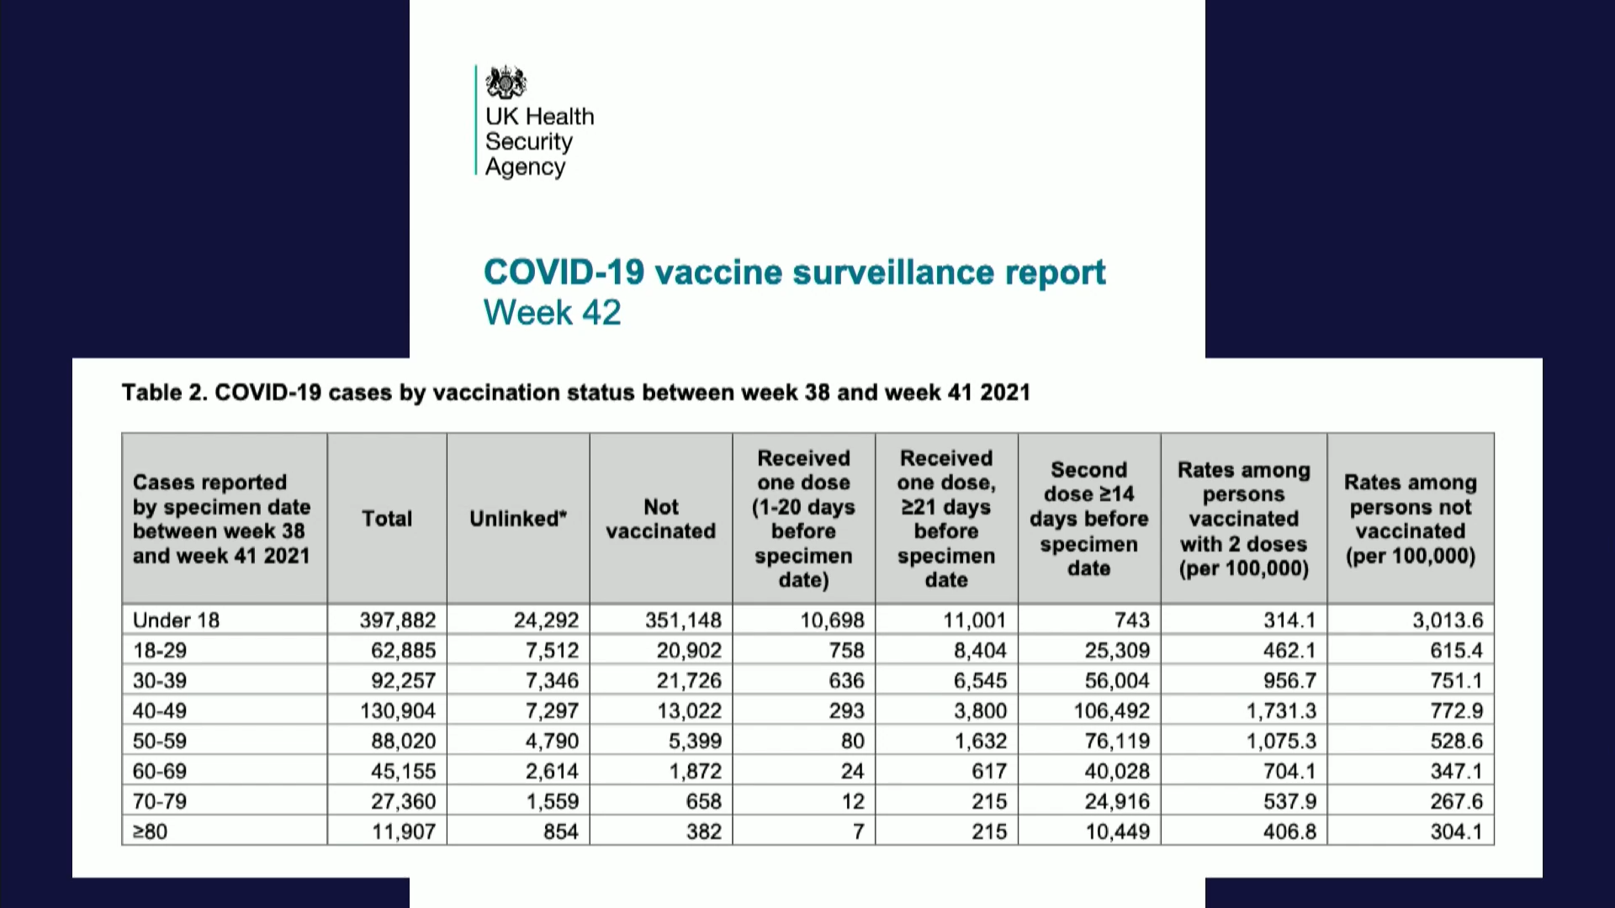

Or, for the same information in the form of a graph:
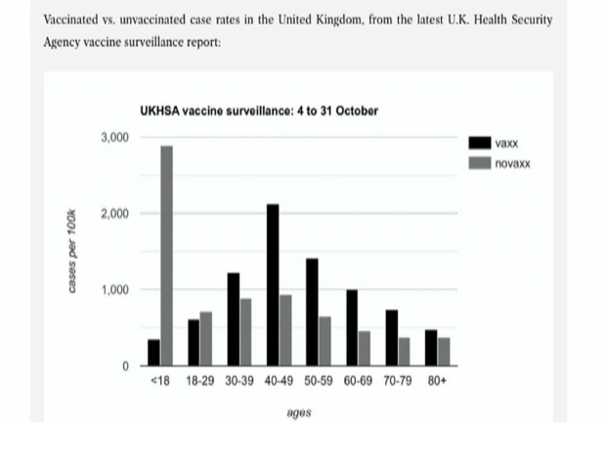
Worryingly, for all age groups above 30, we see that the cases of Covid are far higher in those that have been vaccinated than for those that have not been vaccinated.
The same situation is reported in the USA. Following an assessment of all the available research literature on the Covid vaccines, Professor Allon Friedman from the Indiana University School of Medicine concludes:
“The Pfizer and Moderna trials show that in lower risk populations (which account for most of society) COVID-19 vaccines do not reduce mortality. Therefore, vaccine mandates, which are enormously costly and terribly divisive, are a cure worse than the disease.” [our bold]

Concerns over fertility, pregnancy and still births
Other concerns over the vaccines are also gathering momentum. Recent data available from Public Health Scotland shows that cases of ovarian cancer in 2021 are much higher than the 2017-2019 average. Deaths of new-born babies have also reached the upper warning threshold, indicating that factors beyond random variation may have contributed to the deaths. With nearly 40,000 menstrual disorders reported as adverse reactions to the Covid-19 vaccines, scientists also warn of potential issues with infertility. Real world data shows the rate of miscarriage following Covid 19 vaccination is as high as 82%.
We find that mainstream news is reluctant to attribute these problems to the vaccine program, and remains silent on the matter.
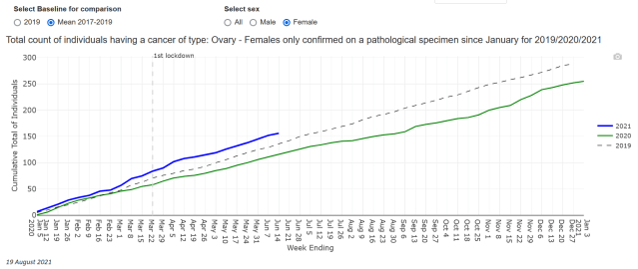

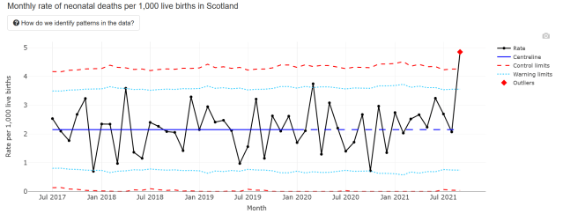
It is not clear why the UK government continues to recommend vaccines for pregnant women, especially given the warnings it highlights in its own official report. The report, prepared upon the emergency authorisation of the Pfizer mRNA Covid-19, suggests safety concerns. It states that the Pfizer jab was not recommended for use during pregnancy, and that before receiving a jab, it was important to rule out any chance that a woman was pregnant. It goes on to say that women of child-bearing age should avoid pregnancy for at least 2 months after their second dose.
Similar concerns were raised over a study on pregnant women receiving the vaccine, as it was found that the Covid-19 vaccine candidates could trigger an immune reaction against a human protein responsible for the formation of the placenta. The possible damage to mother and baby was spelt out in a report presented to the European Medicines Agency (EMA) in December 2020, issued by Dr Wolfgang Wodarg a medical doctor and epidemiologist (also a member of the Bundestag, German Federal Parliament, from 1994 to 2009), and Dr Mike Yeadon, a former vice president of Pfizer, where he spent 16 years as an allergy and respiratory researcher. But despite their concerns, the phase 3 trials went ahead.

Concern deepens in light of the UK government’s decision to offer all pregnant women the Pfizer jab, from April 2021 – despite no scientific studies to confirm the safety of the use of the Pfizer vaccine during pregnancy. The recommendation came from the Joint Committee of Vaccination and Immunisation (JCVI), citing ‘real world data from the United States’, which purported to show that pregnant women had been vaccinated without any safety concerns being raised; and that the rate of miscarriage was just 12.6%. Deeper analysis of the study shows that of the 127 women who received the Pfizer or Moderna Covid-19 vaccines during the first-second trimester, 104 of them sadly lost their babies. What the ‘real world data’ from the USA proved was that the actual rate of miscarriage was as high as 82%.

Concerns over boosters
Because of the waning efficacy of the initial Covid vaccines (calculated at approximately five months or less), booster shots are now deemed to be necessary. Possible side effects are still unknown.
However, we will return to this topic to discuss the mechanism of the Covid vaccines, which work by suppressing certain immune responses in the body – which may include for example, immune responses for keeping cancer in check. This raises concerns for boosters, and repeated boosters (which the government plans to roll out for at least two to three more years). What will be the cumulative effect of shots that continually suppress immune responses in the body?

The success of natural immunity
To offset the worrying news on vaccine efficacy, studies in natural immunity provide a ray of hope. A large and growing body of research shows evidence of robust natural immunity against Covid infection, and – tellingly – against its inevitable variants. One study published in the Lancet found that the risk of repeat infection decreased by 80.5-100%; moreover, only 0.7 became reinfected; 0% became reinfected; and the frequency of death due to repeated infection among the Covid-recovered was only 0.01%:
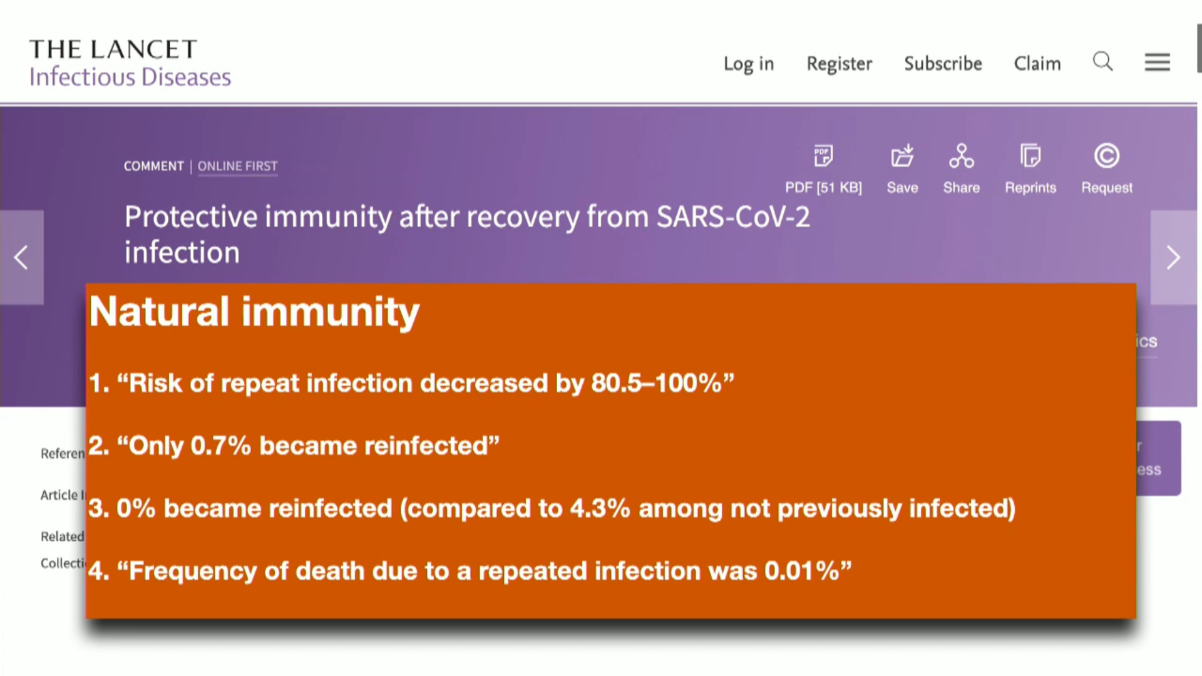

Conclusion
Given the high number of ‘Covid-recovered’ people in the population, we draw hope from studies showing how well natural immunity serves to fight off infection. In comparison, and in the light of the government’s own statistics, the efficacy of the vaccines needs more discussion. Before vaccine mandates are considered, we would suggest a pause to evaluate the evidence. This may open up alternative methods of overcoming the pandemic, such as early intervention treatments (see Early Treatments article).
We would also like the government to curb the strong media narrative that the vaccines are the only route out of the pandemic – and especially its critical stance towards those who are risk-averse to the experimental vaccines. Above all, we ask for special awareness of the risks amongst the younger populations, and for women wanting children.
Urgent discussion is needed on how and why normal regulatory assessment and safety procedures have been waived aside.

References:

www.ons.gov.uk/peoplepopulationandcommunity/birthsdeathsandmarriages/deaths/datasets/preexistingconditionsofpeoplewhodiedduetocovid19englandandwales
www.ons.gov.uk/aboutus/transparencyandgovernance/freedomofinformationfoi/influenzadeathsin20182019and2020
*www.ons.gov.uk/aboutus/transparencyandgovernance/freedomofinformationfoi/averageageofthosewhohaddiedwithcovid19
www.ons.gov.uk/peoplepopulationandcommunity/birthsdeathsandmarriages/deaths/articles/mortalityinenglandandwales/2012-12-17
www.yellowcard.mhra.gov.uk/the-yellow-card-scheme/. Thalidomide was a drug that caused severe damage to many babies, that took five years to come to light: www.pubmed.ncbi.nlm.nih.gov/21507989/
www.bmj.com/content/375/bmj.n2635 Covid-19: Researcher blows the whistle on data integrity issues in Pfizer’s vaccine trial and also see www.dailysceptic.org/2021/11/17/can-anything-about-the-pfizer-vaccine-trial-be-trusted/. There is also widespread discussion of vested interests discovered between pharmaceutical companies, the WHO, and media outlets, which is worth further discussion (See: Comply/Debate).
www.report24.news/ab-13-jahren-lange-liste-ploetzlich-verstorbener-oder-schwerkranker-sportler/ (click google translate from German to English)
www.ahajournals.org/doi/10.1161/circ.144.suppl_1.10712
www.ukfreedomproject.org/campaigns/open-letter-to-mhra-alert-your-mp/
www.hartgroup.org/recent-deaths-in-young-people-in-england-and-wales/
www.bbc.co.uk/news/health-58438669
stuartbramhall.wordpress.com/2021/07/31/dr-peter-mccullough-and-the-suppression-of-early-covid-outpatient-treatment/
https://en.wikipedia.org/wiki/Peter_A._McCullough. It is notable that Wikipedia cites hydroxychloriquine as one of the ‘misinformations’ despite strong support from the medical profession for this drug in early treatment, (e.g. by Havard epidemiologist, Professor Harvey Risch from the Yale School of Public Health and Yale School of Medicine); it also remains silent on the efficacy of Dr McCullough’s early treatment protocol based on a large body of independent research (See: More on Covid Cure).
www.ukcolumn.org/article/why-we-must-question-vaccine-efficacy-and-safety-claims
Professor Allon Friedman, at Indiana University School of Medicine: Vaccine Mandates: Unscientific, Divisive, and Enormously Costly ⋆ Brownstone Institute
Information for Healthcare Professionals on COVID-19 Vaccine Pfizer/BioNTech (Regulation 174) - GOV.UK (www.gov.uk)
https://2020news.de/wp-content/uploads/2020/12/Wodarg_Yeadon_EMA_Petition_Pfizer_Trial_FINAL_01DEC2020_EN_unsigned_with_Exhibits.pdf
Official Data shows huge increase in cases of Ovarian Cancer, and Deaths of New-Born Babies have hit Critical Levels; are the Covid-19 Vaccines to blame? – The Expose (dailyexpose.uk)
www.thelancet.com/journals/laninf/article/PIIS1473-3099(21)00676-9/fulltext

