Do the unvaccinated pose a risk to the vaccinated?
As the government moves towards its goal of 100% vaccination, society starts to divide. On ‘one side’ are those who see Covid as a severe threat, and vaccination and boosters as the way out of the pandemic. On the ‘other side’, are people more risk-averse to the Covid vaccines than to Covid itself, who are seen as a threat. Thus, heavy pressure to accept the vaccines is found across the world. This ranges from loss of employment, to new laws to curb those speaking out against government health policy, to threats of imprisonment and even forced vaccination and/or detention. The serious threat posed by Covid is the justification for such ‘penalties’, which the government hopes will protect the health of the nation and its economy.
Forcible intervention is already established and deemed acceptable in certain cases where there ‘is a risk to public health as a result of rabies, cholera or tuberculosis’. In most other cases (except in cases where the patient is mentally unfit, or physically incapacitated), consent is required by law. To breach consent also breaches the once-inviolable codes of the Nuremberg Charter / Nuremberg Code; the UNESCO Universal Declaration on Bioethics and Human Rights; the UN International Covenant on Civil and Political Rights and the UN Universal Declaration of Human Rights. For governments to apply duress in the case of Corona vaccines, they must be able to show that, (1) the unvaccinated pose a risk of transmission as severe as ‘rabies etc.’, and (2) that the disease itself poses a severe risk. We address both issues here.

So, how dangerous are the Unvaccinated?

In order to assess this, we need to take a closer look at the following:
- Viral loads;
- Vaccine efficacy;
- Natural immunity; and
- Excess deaths.

- Viral loads
Studies have been undertaken to test both vaccinated and unvaccinated Covid patients to determine the extent of the viral load in each. The evidence indicates that there is no difference between the two groups. As such the Covid vaccines do not appear to decrease the possibility of passing infections to others.
- Vaccine efficacy
At the start of the vaccine roll-out, the Government and media were emphatic that the vaccines were ‘95% effective’. It is worth noting that efficacy (e.g. ‘95% effective’) actually describes ‘relative risk’ reduction: the relative risk of catching Covid is reduced by 95% if you take the vaccine. In fact, the metric we need is not ‘relative risk’ but rather ‘absolute risk’; that is, the ‘absolute risk reduction of catching Covid. When you calculate the “absolute risk” it turns out to be only a 1% risk reduction.
Using the term ‘vaccine’ may also be misleading, because, unlike traditional vaccines, the new MRNA drug does not immunize you or prevent you from catching the virus, nor stop you from spreading the virus to others – a fact already well known, as it has received wide coverage. Boris Johnson himself has explained this, and the pharmaceutical manufacturers agree: their Covid vaccines are effective in reducing the seriousness of the Covid infection, but have little bearing on contagion or transmission.
This is borne out by data provided by PHE (Public Health England, prior to its name change to HSA, Health and Safety Authority). Taking a snapshot of in three weeks in September 2021 (weeks 36 – 39) for all age groups above 30, we can see that rates of Covid cases are higher in those that have been vaccinated than for those that have not been vaccinated.
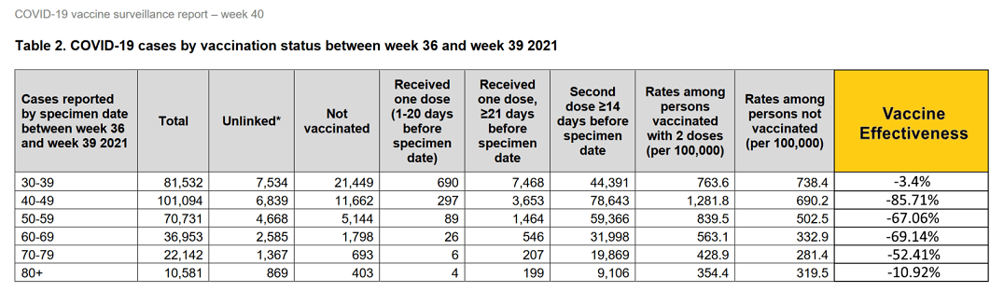

This same is true for a snapshot of the data for week 42 (18th October 2021) of the pandemic, again using data from the UK HSA:

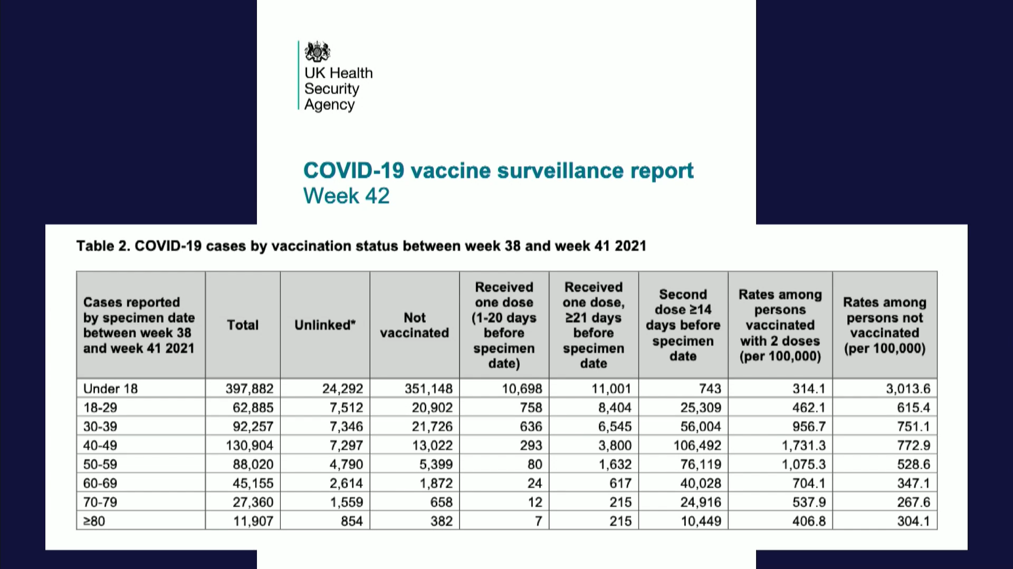
Or, for the same information in the form of a graph:
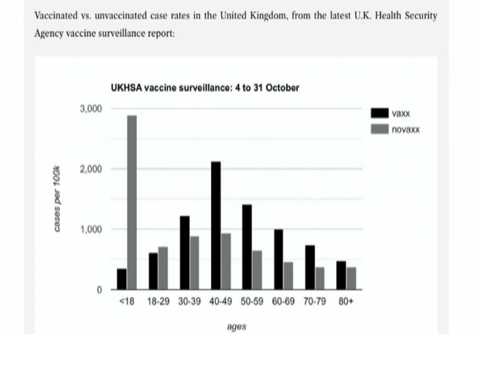
These figures raise important questions. Is governmental pressure to accept the vaccine consonant with the government’s own data? Is it right to place non-vaccinated people under duress – and so to breach time-honoured legal codes – when available data shows that vaccination has little discernible impact on either neither transmission or efficacy?
- What about natural immunity?
A large number of studies are increasingly showing evidence of robust natural immunity from natural Covid infection. One such study published in The Lancet (screenshot below) found that, 1. the risk of repeat infection decreased by 80.5-100%; 2. only 0.7% became reinfected; 3. 0% became reinfected (compared to 4.3% among those not previously infected); 4. “Frequency of death due to repeated infection was 0.01%”. If natural immunity is as strong as The Lancet study shows, then is there any reason for enforcing vaccine mandates on the Covid-recovered, or those with proven immunity?
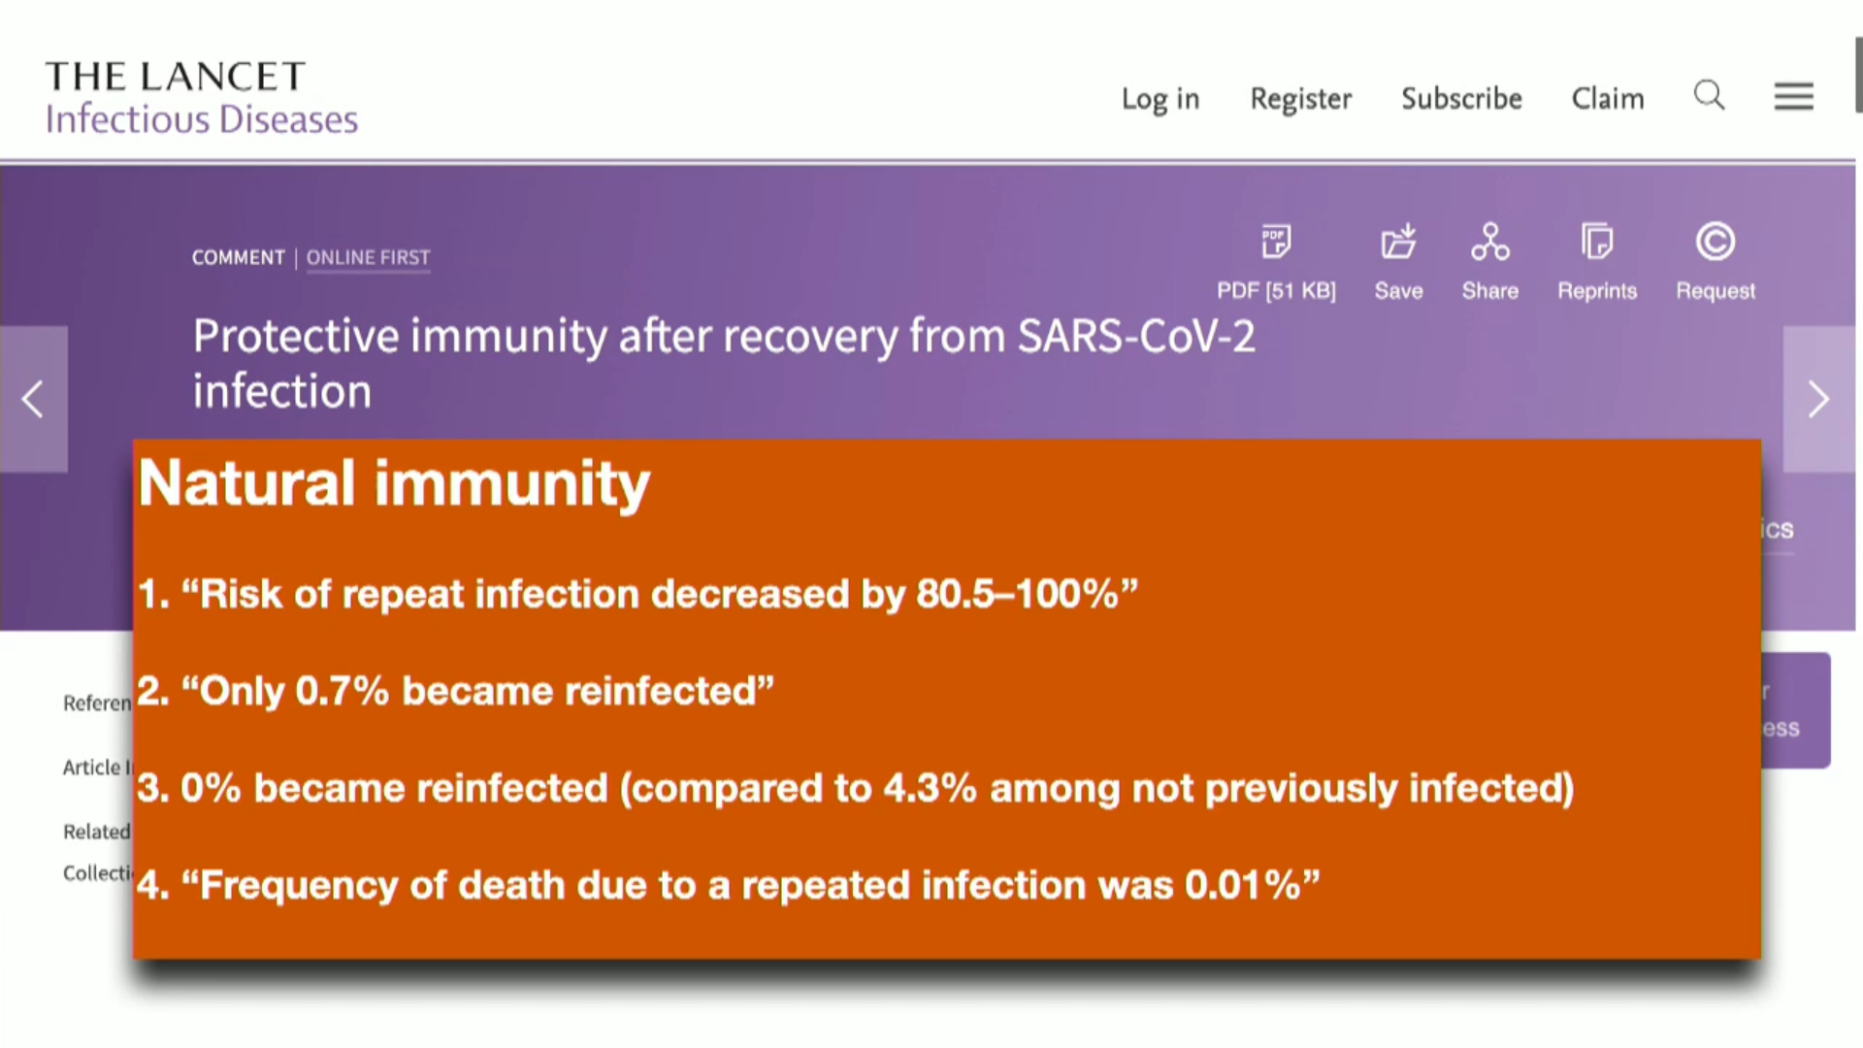
- Excess deaths, age groups 10 to 59
Recent ONS statistics (see graph below) show that deaths in under 60s is higher among those that have been vaccinated than those who have not been vaccinated. Before governments enforce mandates on the unvaccinated population, it may be worth pausing to ask what the cause of this unexpected discrepancy may be? We need to understand the causes of the increased death rates among the vaccinated.
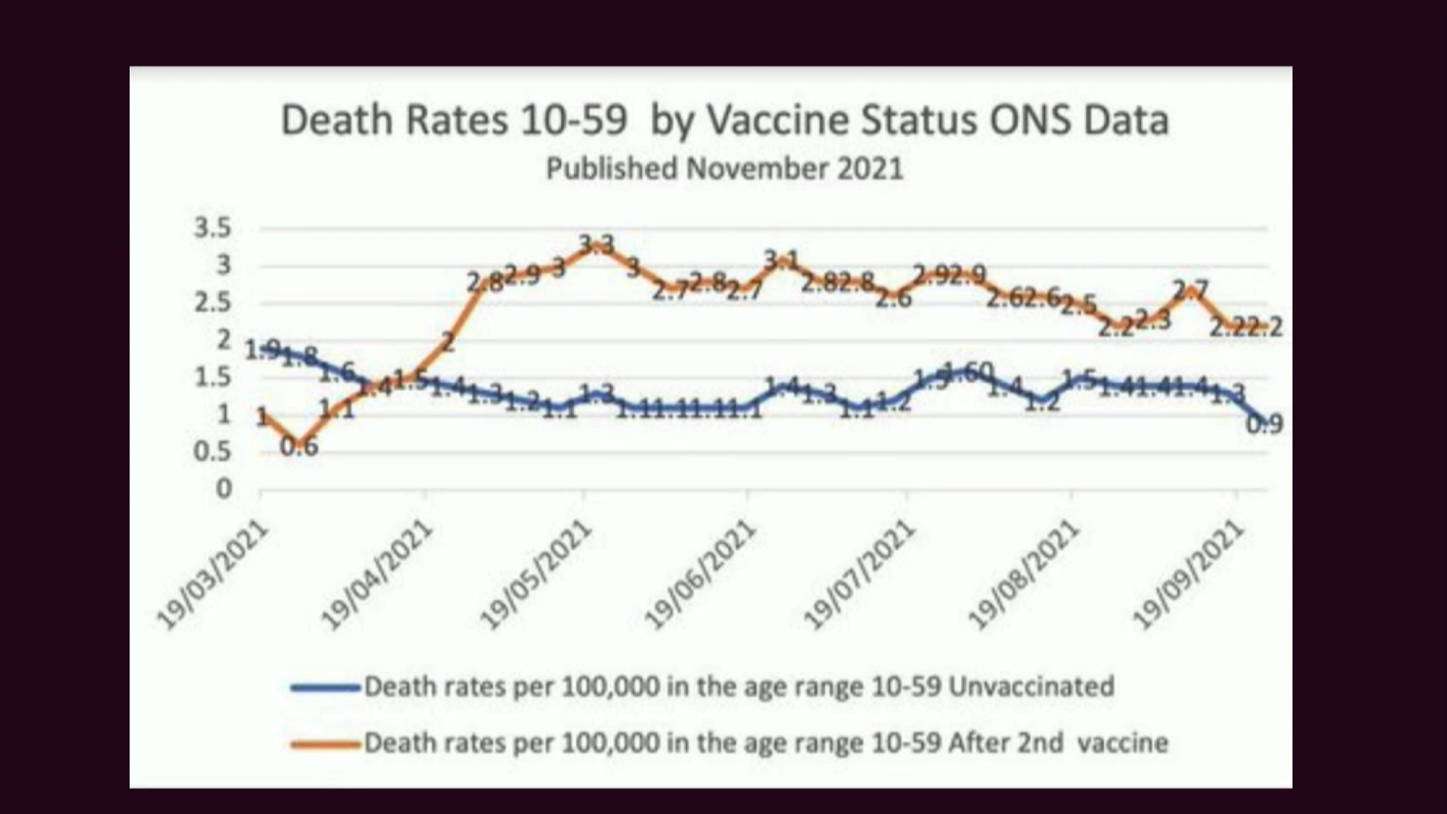
Conclusions
In the light of the government’s own statistics, and recent research on natural immunity, it is increasingly hard to understand the Government’s claims that vaccination is the best/only route out of the pandemic. Its own data shows that unvaccinated people pose no greater risk to those who have received the vaccines, nor to those who are not vaccinated. According to its own statistics, the vaccinated are more likely to catch Covid than the unvaccinated.
Are these findings enough to reassess the current trend to see unvaccinated people as a ‘threat’? Can we compare an unvaccinated person to someone with ‘rabies, cholera or tuberculosis’, or to the mentally unstable or incapacitated (as per the current NHS legal position)? Medico-legal practice prior to the pandemic would answer with an emphatic ‘no’. Yet a significant majority seem willing to accept mandates that create a two-tier society and deprive people of their livelihood. Some governments are able to enforce vaccination on people who oppose it – in a clear violation of the freedoms upheld, protected, and enshrined in law since the holocaust of the second world war. It is time to ask: what has changed?

Footnote references

Compulsory Covid Vaccination for All in Austria as of February 2022: www.vindobona.org/article/explained-compulsory-covid-vaccination-for-all-in-austria-as-of-february-2022 Phased introduction of Covid mandates in Western Australia: COVID-19 coronavirus: Mandatory COVID-19 vaccination information (www.wa.gov.au)
https://www.nhs.uk/conditions/consent-to-treatment/
www.en.unesco.org/themes/ethics-science-and-technology/bioethics-and-human-rights
www.ohchr.org/EN/ProfessionalInterest/Pages/CCPR.aspx
www.un.org/en/about-us/universal-declaration-of-human-rights
6 Studies on Viral loads: Viral Loads Similar Between Vaccinated and Unvaccinated People: www.ucdavis.edu/health/covid-19/news/viral-loads-similar-between-vaccinated-and-unvaccinated-people. Also: www.un.org/en/about-us/universal-declaration-of-human-rights. Also, studies on Covid-19: From the BMJ: Fully vaccinated people can carry as much delta virus as unvaccinated people, data indicate: www.bmj.com/content/374/bmj.n2074. Also: 11 Oct 2021 – ‘Transmission of SARS-CoV-2 Delta Variant Among Vaccinated Healthcare Workers, Vietnam’: "Viral loads of breakthrough Delta variant infection cases were 251 times higher than those of cases infected with old strains detected between March-April 2020. Time from diagnosis to PCR negative was 8–33 days (median: 21). Neutralizing antibody levels after vaccination and at diagnosis of the cases were lower than those in the matched uninfected controls. There was no correlation between vaccine-induced neutralizing antibody levels and viral loads or the development of symptoms." , Also: <https://papers.ssrn.com/sol3/papers.cfm?abstract_id=3897733> , Also: in The Lancet, 29 Oct 2021 – ‘Community transmission and viral load kinetics of the SARS-CoV-2 delta (B.1.617.2) variant in vaccinated and unvaccinated individuals in the UK: a prospective, longitudinal, cohort study’: "fully vaccinated individuals with breakthrough infections have peak viral load similar to unvaccinated cases and can efficiently transmit infection in household settings, including to fully vaccinated contacts" <https://www.thelancet.com/journals/laninf/article/PIIS1473-3099(21)00648-4/fulltext>. Also on Shedding of Infectious SARS-CoV-2 Despite Vaccination: 6 Nov 2021 (latest version. 6th version) - "To determine whether infectious virus titers differed in vaccinated and unvaccinated persons, we performed plaque assays on an additional set of 48 samples with Ct <25, finding no difference in infectious virus titer between groups."<https://www.medrxiv.org/content/10.1101/2021.07.31.21261387v6.full>
Article on vaccine efficacy: www.ukcolumn.org/article/why-we-must-question-vaccine-efficacy-and-safety-claims
Increase in Vaxxed getting covid: www.thelancet.com/pdfs/journals/lanepe/PIIS2666-7762(21)00258-1.pdf
Lifetime antibodies article in Nature: www.nature.com/articles/d41586-021-01442-9
Natural immunity article in the Lancet: www.thelancet.com/journals/laninf/article/PIIS1473-3099(21)00676-9/fulltext

